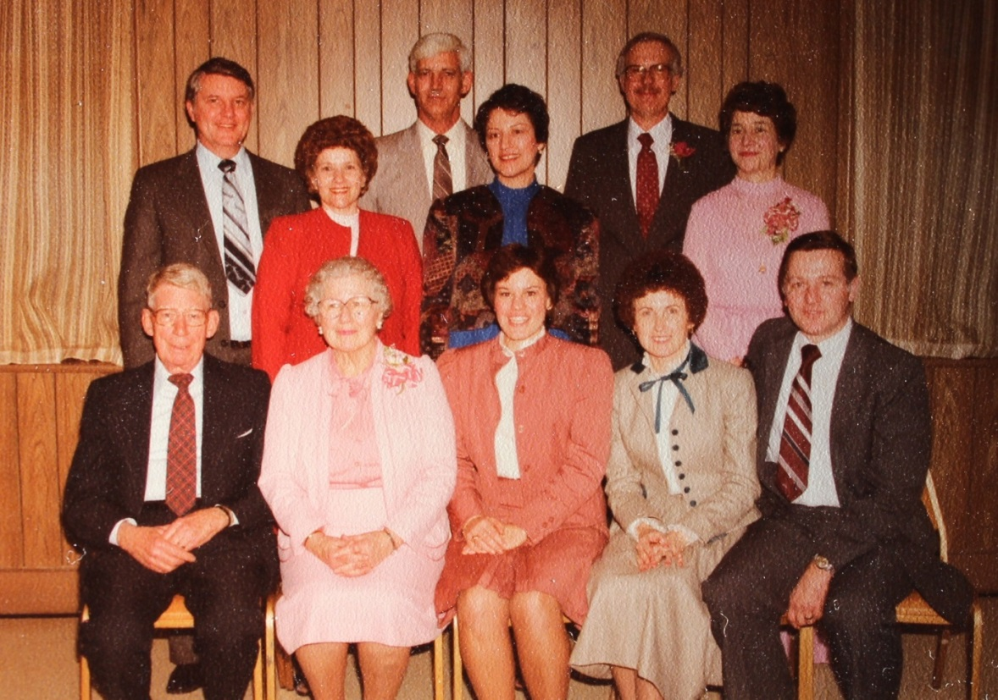

(l-r) Standing: David & Carolyn; Don & Dottie List Raasch; Ronald & Jo Ann List

Gordon & Dorothy Wolfe List Worthen; Brenda List Huffines;

and Jeanette & Mark List – about 1975 (est.)

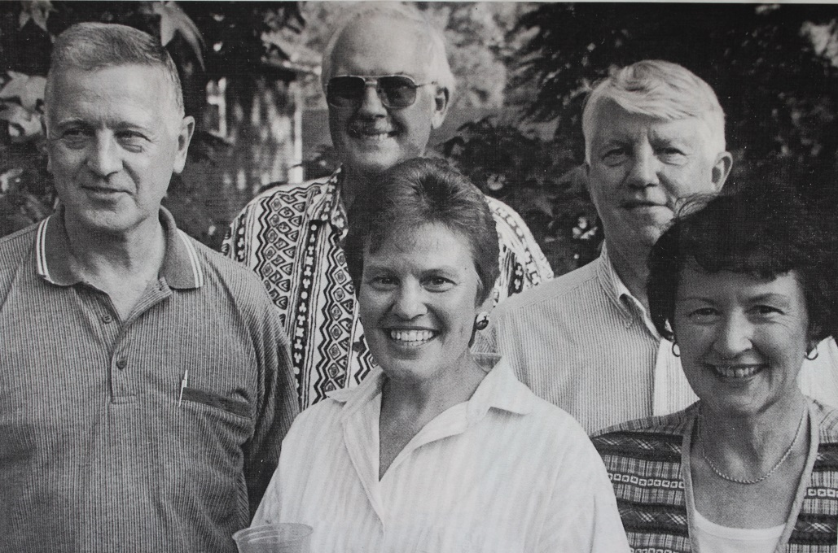

(l-r) Mark, Ronald, David, Brenda, and Dorothy List – about 2000 ??